Name: Wang Zihao

Student number: A0204706M

Week 5 Studio 1

Group 4b

10th September 2019

1. Electrolytic and super capacitors have polarity. I will ensure that the polarities are correct before turning on the power supply.
2. I will wear protective goggles when the circuits are powered.

**Activity #1: Appreciating the energy storage capability of capacitors**

|  |  |
| --- | --- |
| Capacitor C | Duration that the LED lights up (s) |
| Single 2200μF capacitor | 0.93 |
| Two 2200μF capacitors in parallel | 1.66 |
| Single 1F supercapacitor | > 1min |
| 1F supercapacitor in series with a 2200μF capacitor | 0.70 |

From the table, the duration that the LED lights up: 1F supercapacitor in series with a 2200μF capacitor < Single 2200μF capacitor < Two 2200μF capacitors in parallel < Single 1F supercapacitor

As E = C and E = Pt, C= Pt, C ∝ t

The duration of the LED lights up (i.e. time taken for capacitor to be discharged) is directly proportional to the effective capacitances of the capacitors.

Capacitance of 2200μF capacitor = 2200μF

Capacitance of two 2200μF capacitors in parallel = 2200 +2200 = 4400μF

Capacitance of single 1F supercapacitor = 1F

Capacitance of 1F supercapacitor in series with a 2200μF capacitor = = 2195μF (4s.f.)

From the calculation, the capacitance of the capacitors: 1F supercapacitor in series with a 2200μF capacitor < Single 2200μF capacitor < Two 2200μF capacitors in parallel < Single 1F supercapacitor

Since the capacitance of 1F supercapacitor in series with a 2200μF capacitor is the lowest, its duration is the shortest. Since the capacitance of single 1F supercapacitor is the largest, its duration is the longest.

**Activity #2: Applying DC transient analysis technique to derive the charging voltage characteristics of a capacitor in a given circuit**

1. Vc(0­­-) = Vc(0+) = 0V

Vc(∞) = 2.5V

1. + =0

+ = 0

Va = 2.5V, Vb = 0V

VTH = Va – Vb = 2.5 – 0 = 2.5V

RTH = = 500Ω



1. Time constant τ = RC = 500220010-6 = 1.1s

VC(t) = VC(0) + VC(∞)(1 )

1. Tmeasured for the capacitor’s voltage to reach 63.2% of VC(∞) = 1.04s

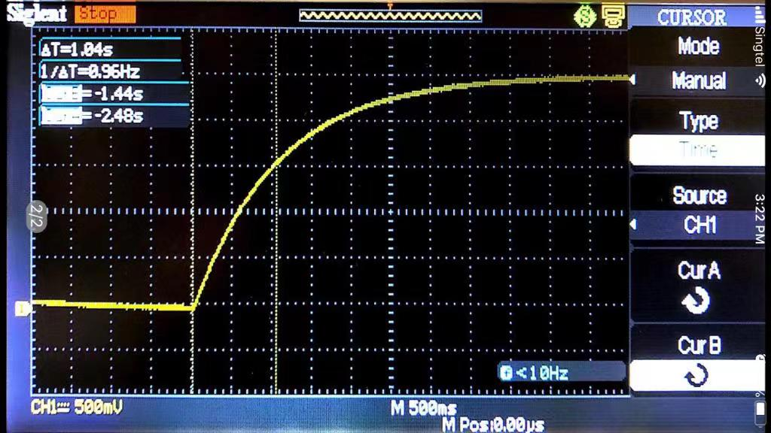

63.2% VC(∞) = VC(0) + VC(∞)(1 )

63.2%2.5 = 0 + 2.5(1 )

0.632 = (1 )

0.632 = 1

t = 1.10s (3s.f.)

Ttheoretical for the capacitor’s voltage to reach 63.2% of VC(∞) = 1.10s

Percentage difference between Ttheoretical and Tmeasured = = 5.45%

Thus measured time is slightly lower than the theoretical value.

One possible source of errors is that the value of the capacitance of the capacitor used may not be exactly 2200μF. Thus time constant τ = RC may not be 1.1s as we used to calculate the theoretical value. Thus there is a slight difference of 5.45% between Ttheoretical and Tmeasured.